**如何介绍一道菜的制作方法**

**写作任务 (Section B 3c)**

假如你是李欣，你的美国笔友Alice很喜欢中国美食，发邮件询问你擅长做哪一道中国菜，并想跟你学做这道菜。请你给她回一封邮件，介绍这道菜的制作方法。

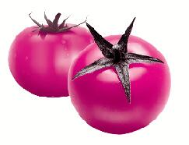

**●【审清题目】**

**内容：**按照做菜先后顺序描述一道菜的制作方法

**文体：**说明文

**时态：**一般现在时

**句式：**介绍食物制作方法时常用祈使句

**●【头脑风暴】**

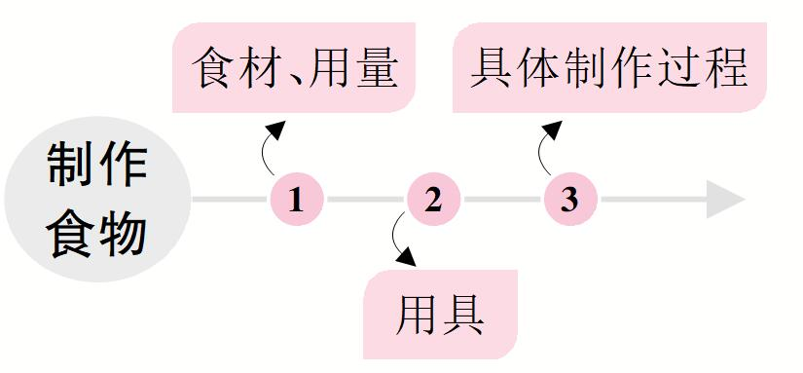

**●【提供素材】**

**◆单词&短语**根据汉语提示，写出对应的英文表达。

|  |  |
| --- | --- |
| **dish** | scrambled eggs (炒蛋), spicy chicken (辣子鸡), caramelized bananas (拔丝香蕉) ... |
| **ingredients**  **(原料)** | Fruits: apples, bananas, pears, strawberries, (1)_______(西瓜), oranges ...  Vegetables: onions, (2)_______(土豆), carrots, lettuces, cabbages, tomatoes, green peppers ...  Others: beef, chicken, fish, mutton, ham (火腿), salt, sugar, (3)_______(胡椒粉), cooking oil (油), vinegar (醋), ginger (生姜), yogurt, honey, butter, milk, flour (面粉), eggs, (4)_______(奶酪) ... |
| **utensils**  **(用具)** | a pot, (5)_______(一个盘子), a bowl, a cup, a glass, a blender, an oven, a pan (平底锅), a wok (炒菜锅), a knife (刀) ... |
| **sequences**  **(顺序)** | first, first of all, firstly, second, secondly, third, thirdly, next, then, (6)_______(在那之后), finally, in the end ... |
| **how to do** | wash, (7)_______(剥皮), pour, add, (8)_______(切碎), mix up, fry (油炸), mash (捣碎), cook, heat (加热), prepare, cover, stir (搅拌), stir-fry (炒菜), cool ... |

**Key:**1. watermelons  2. potatoes  3. pepper  4. cheese

5. a plate  6. after that  7. peel  8. cut up

**◆句型**

• To make scrambled eggs, you need to have / prepare ...

• If you want to cook it, please follow these steps (步骤).

• Put ... into a pot.

• Cook ... for 30 minutes / until they are golden (金黄的).

• Fill ... with ...

• Place ... on the plate.

• Cut ... into (small) pieces.

• Mix everything / ... and / with ...

• You can / have to add some ...

**●【谋篇布局】** 将括号内的汉语翻译成英语，补全短文。

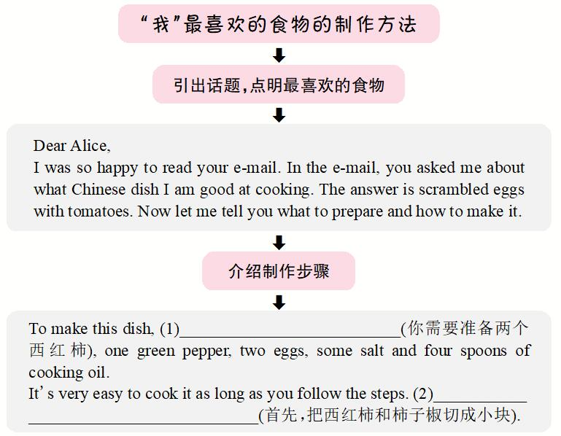

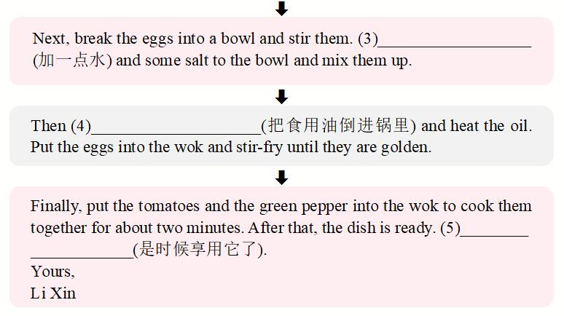

**Key:**

1. you need to prepare two tomatoes

2. First, cut the tomatoes and the pepper into small pieces

3. Add a little water

4. pour the cooking oil into the wok

5. It's time to enjoy it